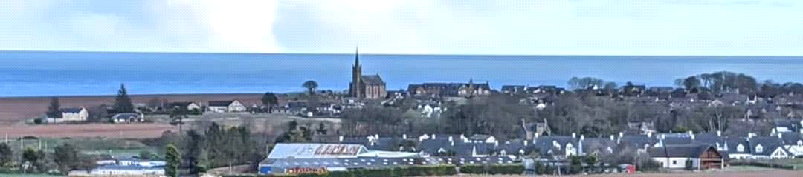
St Cyrus Community Council
Chairperson Peter Moir, Secretary Chris Adam, Treasurer Brian Fleming
Email stcyruscommunitycouncil@gmail.com
24th May 2025
St Cyrus Community Council began looking into the lack of fencing on Beach Road as far back as March 2020. However due to Covid nothing more was done until the council restarted investigations into getting a new fence erected. In November 2023 a few concerned residents once again reaised their concerns about the dangerous condition nfor children nwalkking up to school or going to church.
Previously, a snow fence had been erected, but over time it fell over into the sloping grass. Councillor Alison Evison managed to get Aberdeenshire Council to put up a temporary barrier, but this kept falling over due to high winds, etc.
In April 2025, St Cyrus Community Council sent an application to the Kincardine and Mearns Coastal Communities Fund. Aberdeenshire Council passed this application.
We are glad to inform all that thanks to Lawrie Smith Joinery and a little helper that the fence has been completed and is now safe.
We would like to thank everyone who helped us in our endeavours to get this project completed.

best regards
Chris Adam
Secretary on behalf of St Cyrus Community Council

