

Community Council Report

This report covers progress we have made in dealing with your priorities for the Kincardine and Mearns Community Council area for the period November 2024.

The report aims to highlight emerging issues in your area, provide crime prevention advice and guidance to Community Council members and the residents you represent. Our focus is to reduce crime and disorder, help create safer communities and respond effectively to local concerns.

In this report I will focus on Police Station ‘areas’ as historically these stations would covers the following areas.

Portlethen and surrounding areas including Drumoak and Durris. I will specify this as Portlethen.

Stonehaven Police Station – Stonehaven, Newtonhill, Drumlithie and surrounding areas. I will specify this as Stonehaven.

Laurencekirk Police Station – Laurencekirk and surrounding areas including Fettercairn, Edzell woods, Auchenblae and Garvock. I will specify this as Laurencekirk.

The A92 towns (Catterline – St Cyrus) along the coastal Road are covered between Stonehaven and Laurencekirk but I will specify them as Coastal Road.

Community Policing Priorities

Antisocial behaviour, Violence and Disorder:
Area | Youth Disorder | Anti-Social
Portlethen | 7 | 4
Stonehaven | 7 | 16
Laurencekirk | 1 | 4
Coastal Road | 0 | 5

Acquisitive Crime: D – Detected UI-Under Investigation
Area | Thefts | Shopliftings | Theft of motor vehicle | Housebreakings/Attempts
Portlethen | 1D,1UI | 3D,1UI | 0 | 0
Stonehaven | 2UI | 3D,3UI | 0 | 0
Laurencekirk | 2UI | 0 | 0 | 2UI
Coastal  Road | 0 | 0 | 0 | 0

Road Safety & road crime:

Area | Careless Driving | Drink/Drug Driving | Dangerous
Portlethen | 6D,1UI | 1D,1UI | 0
Stonehaven | 4D,1UI | 1D | 1UI
Laurencekirk | 0 | 0 | 0
Coastal Road | 1UI | 0 | 0

Community Engagement & Reassurance:

Joint report see December’s

Social Media releases of the month –
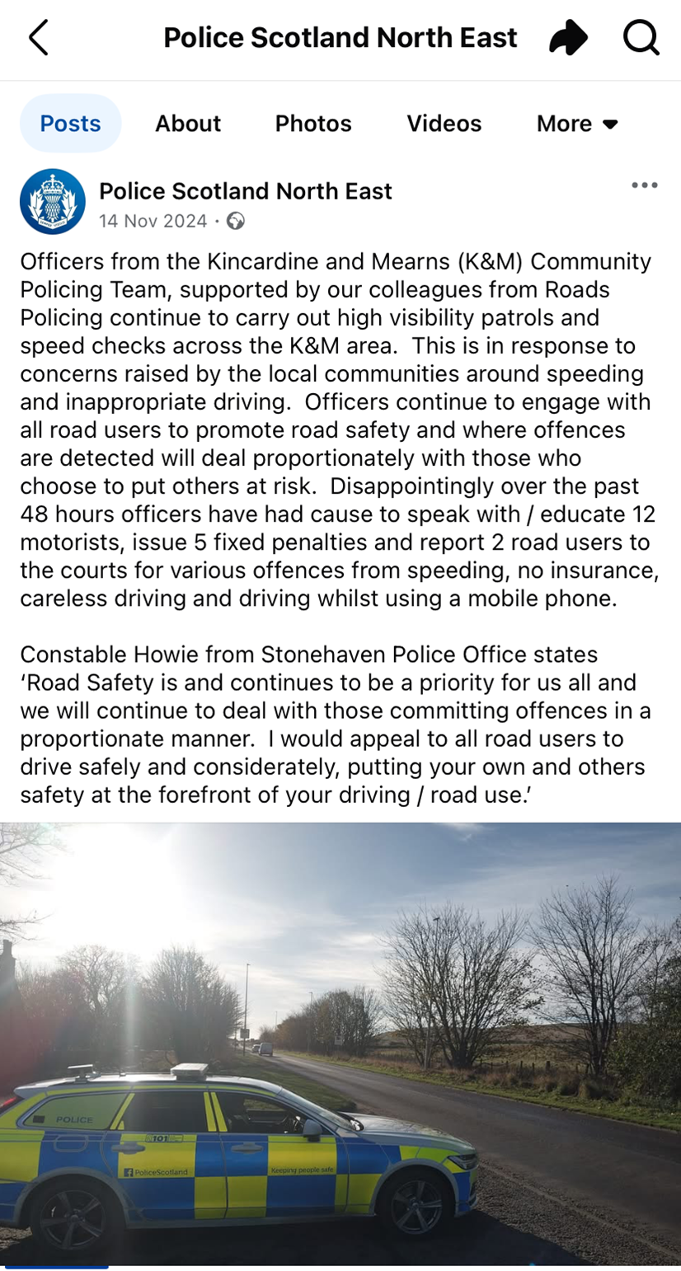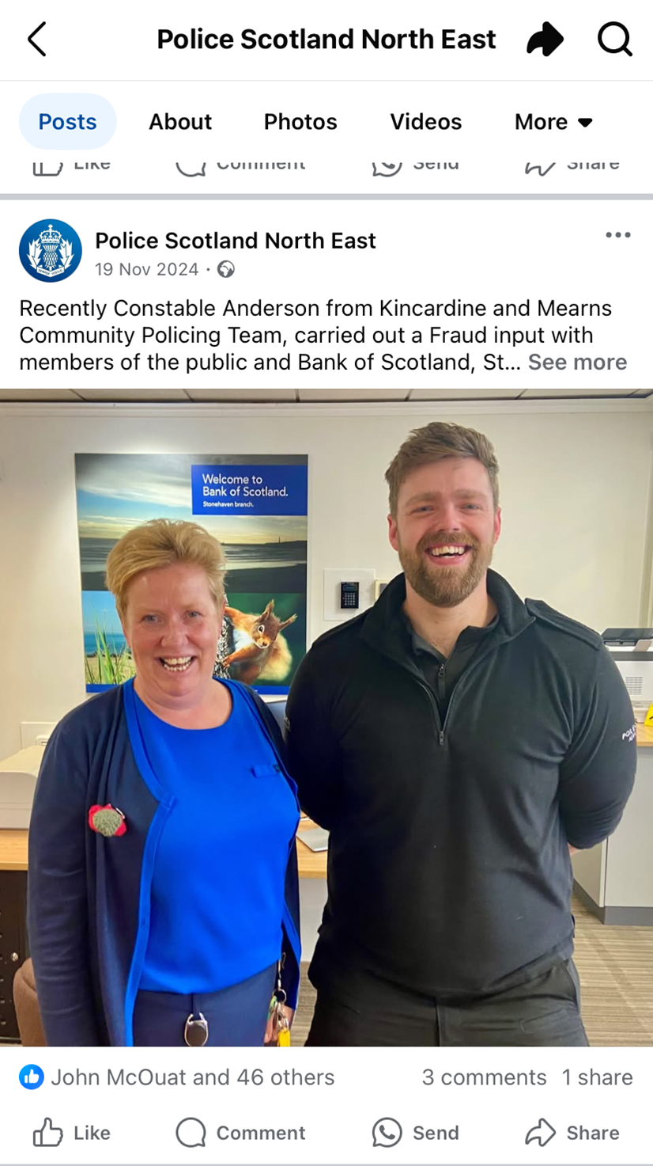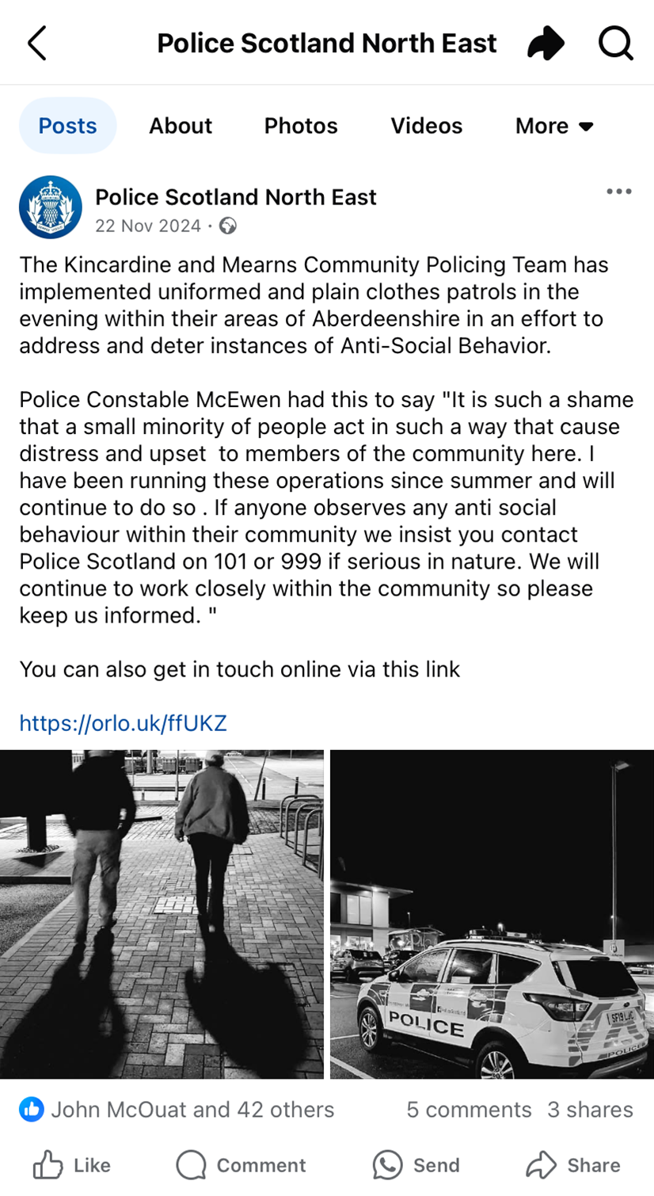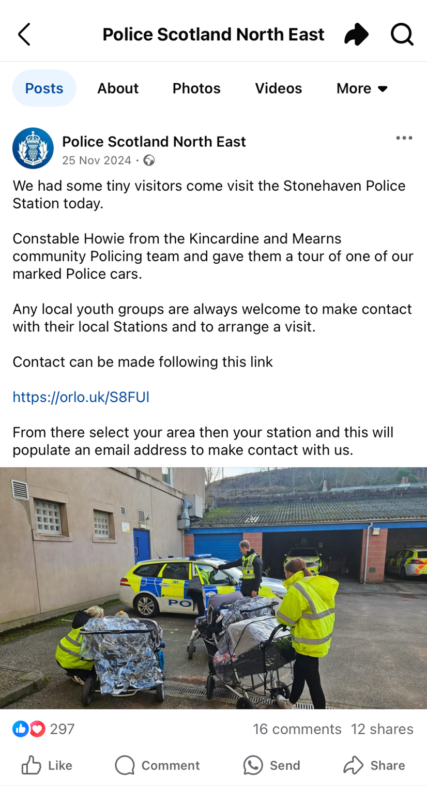

Many thanks,

Inspector Rhona Di Meola
Kincardine and Mearns Community Policing Team
27/12/2024

