

Community Council Report

This report covers progress we have made in dealing with your priorities for the Kincardine and Mearns Community Council area for the period December 2024.

The report aims to highlight emerging issues in your area, provide crime prevention advice and guidance to Community Council members and the residents you represent. Our focus is to reduce crime and disorder, help create safer communities and respond effectively to local concerns.

In this report I will focus on Police Station ‘areas’ as historically these stations would covers the following areas.

Portlethen and surrounding areas including Drumoak and Durris. I will specify this as Portlethen.

Stonehaven Police Station – Stonehaven, Newtonhill, Drumlithie and surrounding areas. I will specify this as Stonehaven.

Laurencekirk Police Station – Laurencekirk and surrounding areas including Fettercairn, Edzell woods, Auchenblae and Garvock. I will specify this as Laurencekirk.

The A92 towns (Catterline – St Cyrus) along the coastal Road are covered between Stonehaven and Laurencekirk but I will specify them as Coastal Road.

Community Policing Priorities

Antisocial behaviour, Violence and Disorder:
Area | Youth Disorder | Anti-Social
Portlethen | 3 | 6
Stonehaven | 4 | 11
Laurencekirk | 0 | 1
Coastal Road | 1 | 13

Acquisitive Crime: D – Detected UI-Under Investigation
Area | Thefts | Shopliftings | Theft of motor vehicle | Housebreakings/Attempts
Portlethen | 2UI | 1D,2UI | 0 | 1UI
Stonehaven | 1D,2UI | 1D,2UI | 0 | 1UI
Laurencekirk | 1UI | 0 | 0 | 1UI
Coastal  Road | 0 | 0 | 1UI | 1UI

Road Safety & road crime:

Area | Careless Driving | Drink/Drug Driving | Dangerous
Portlethen | 2UI | 1D | 0
Stonehaven | 1D,2UI | 1D,3UI | 1D
Laurencekirk | 1UI | 0 | 0
Coastal Road |  | 0 | 0

Community Engagement & Reassurance:

With the colder temperatures I think this advice from our website (Winter Road Safety - Police Scotland) is valid and of use to all members of our community.

Winter road safety

Road safety advice for pedestrians, cyclists and drivers in winter conditions.

Winter means changes in the roads, shorter days and changing weather.

We all have a responsibility to keep Scotland’s roads safe during the winter months.

Advice for pedestrians

Advice if you are out walking during winter:
- Dress for the weather by wearing reflective or bright-coloured clothing so other road users can see you when it's dark or visibility is poor
- If you are walking home late at night, make sure someone knows where you're going and when
- Vehicles can take up to ten times longer to stop on slippery road surfaces so take extra care crossing the road
- Stick to pedestrian crossings
- If there are no crossings nearby, find a place with a clear view and wait for long gaps in the traffic before crossing the road
- Don't cross the road between parked vehicles, unless it can't be avoided then take extra care (look out for vehicles that suddenly pull out or reverse)
- Never cross the road behind a bus
- If there is no pavement, keep to the right hand side of the road so you can see traffic coming towards.

Advice for cyclists

Advice to consider if you are cycling during winter:
- Make sure your bike can be seen by people on the road
- Use a good set of front and rear lights (white at the front, red at the back)
- Wear clothes that help you be seen on your bike, such as bright and light reflective items
- Pay attention to road signs, markings and particularly red lights
- Do not cycle on the pavements, they may be slippery and can also endanger pedestrians
- Be mindful of the effects poor weather can have on other road users
- Make sure you know about the dangers around you
- Cars can take twice as long to stop in wet weather
- Braking can be unpredictable in ice and snow.

Advice for drivers

Advice for drivers during winter:
- Make sure your car is ready for winter
- Check that your tyres, brakes, windscreens, wiper blades and windows are free from defects and clean
- Drive to the road conditions. Road conditions can change without warning, stopping distances will be affected by the weather
- Make sure your windows are clean and aren't misted up
- Make sure there is no snow and ice on your windows before you drive
- When the roads are icy, drive at a slow speed in a high gear
- Accelerate and brake very gently
- Driving distracted (for example, using a Sat Nav) can cause additional stress. It is dangerous to yourself, passengers and other road users.

Social Media releases of the month –

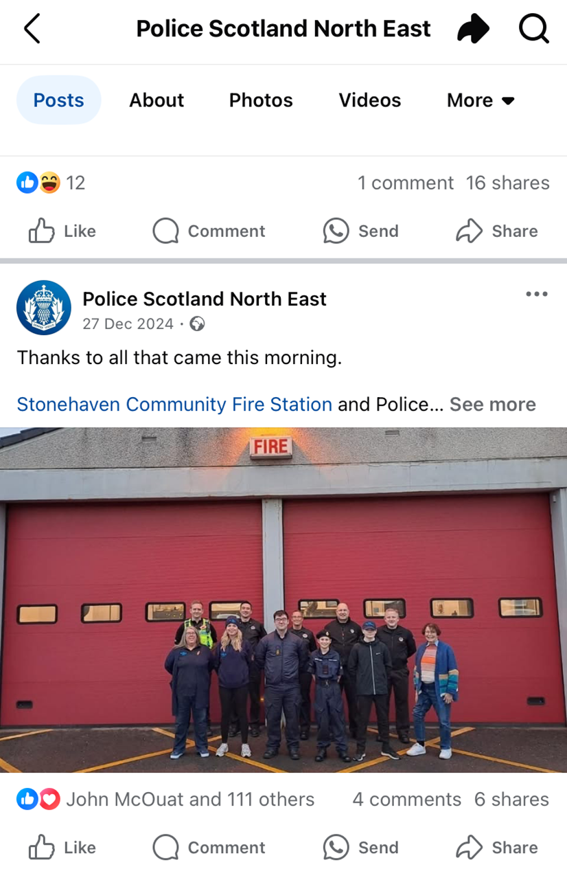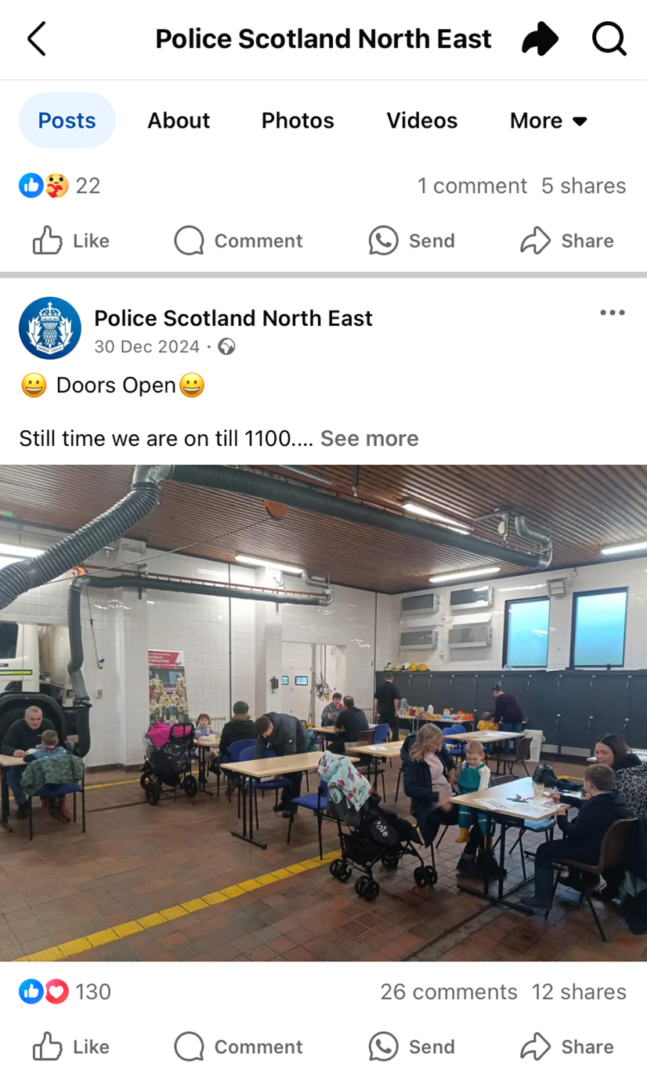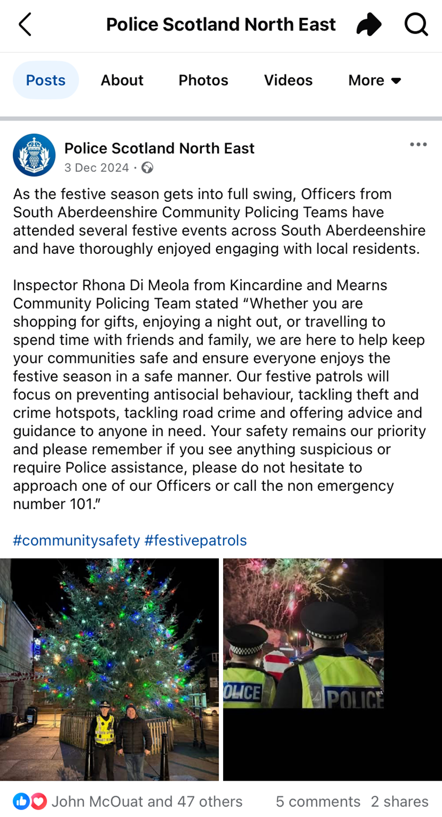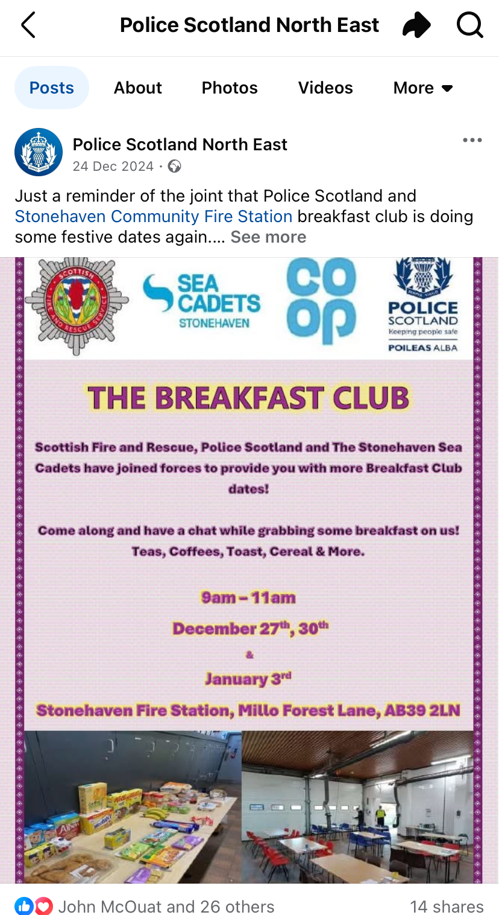

Many thanks,

Inspector Rhona Di Meola
Kincardine and Mearns Community Policing Team
10/01/2025

