

Community Council Report

This report covers progress we have made in dealing with your priorities for the Kincardine and Mearns Community Council area for the period September 2024.

The report aims to highlight emerging issues in your area, provide crime prevention advice and guidance to Community Council members and the residents you represent. Our focus is to reduce crime and disorder, help create safer communities and respond effectively to local concerns.

In this report I will focus on Police Station ‘areas’ as historically these stations would covers the following areas.

Portlethen and surrounding areas including Drumoak and Durris. I will specify this as Portlethen.

Stonehaven Police Station – Stonehaven, Newtonhill and surrounding areas. I will specify this as Stonehaven.

Laurencekirk Police Station – Laurencekirk and surrounding areas including Fettercairn, Edzell woods, Auchenblae and Garvock. I will specify this as Laurencekirk.

The A92 towns (Catterline – St Cyrus) along the coastal Road are covered between Stonehaven and Laurencekirk but I will specify them as Coastal Road.

Community Policing Priorities

Antisocial behaviour, Violence and Disorder:
Area | Youth Disorder | Anti-Social
Portlethen | 13 | 5
Stonehaven | 4 | 15
Laurencekirk | 1 | 2
Coastal Road | 2 | 6

Acquisitive Crime: D – Detected UI-Under Investigation
Area | Thefts | Shopliftings | Theft of motor vehicle | Housebreakings/Attempts
Portlethen | 1UI | 4UI | 0 | 0
Stonehaven | 1UI | 7UI | 0 | 2UI
Laurencekirk | 0 | 0 | 1UI | 5UI
Coastal  Road | 0 | 0 | 0 | 0

Road Safety & road crime:

Area | Careless Driving | Drink/Drug Driving | Dangerous
Portlethen | 2D,1UI | 0 | 1D
Stonehaven | 4D | 5D | 1D
Laurencekirk | 1D | 1D | 0
Coastal Road | 0 | 1UI | 0

Community Engagement & Reassurance:

See this extract from the October edition of Crime Alert. Should you want to read entire copy then find attached to email a PDF.

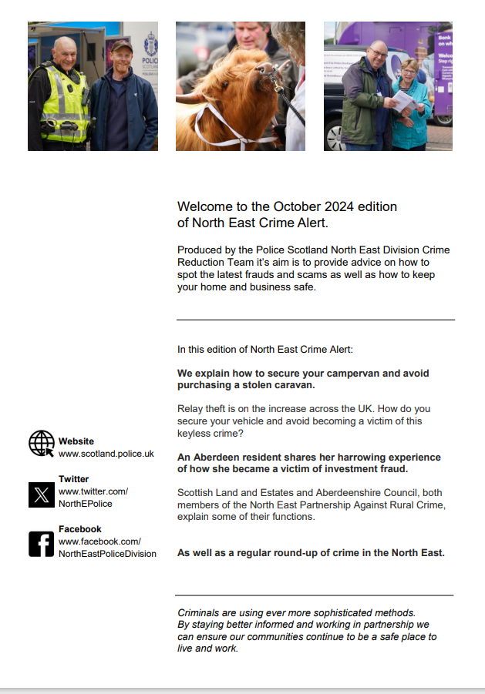

Social Media releases –

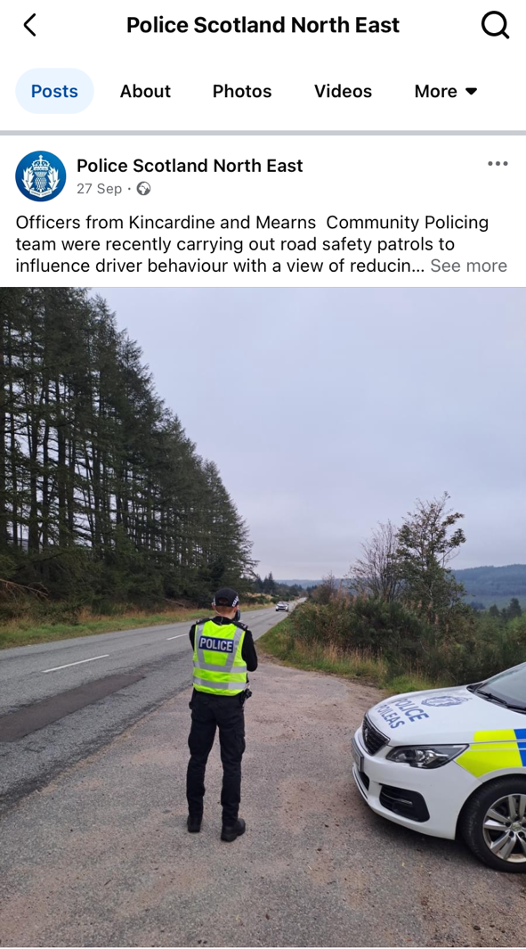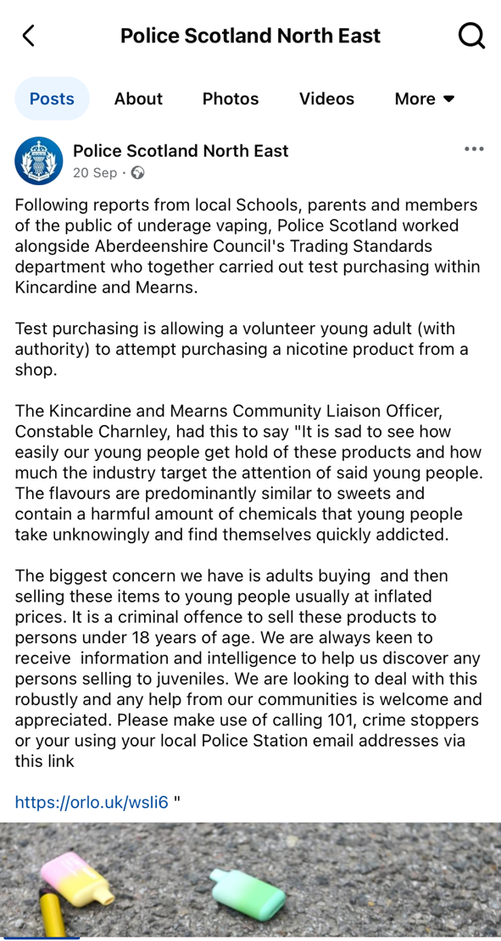

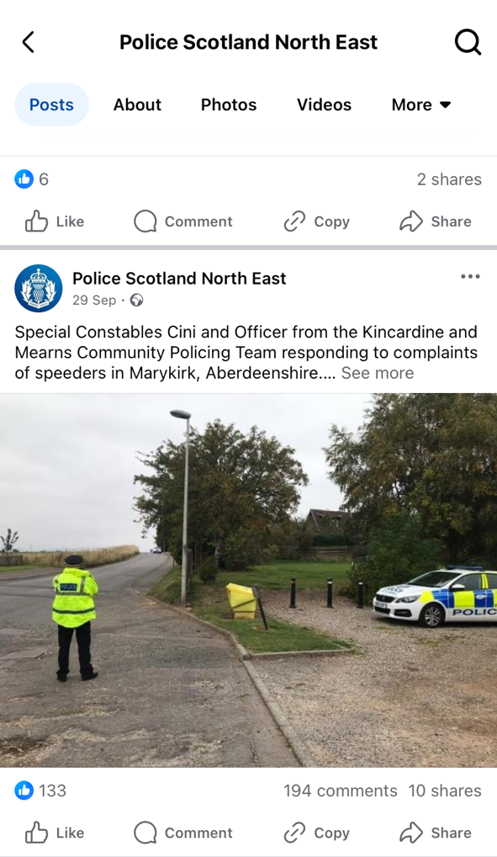

Lastly see attached to email our poster for joint breakfast club alongside SFRS at their Fire Station Stonehaven see time and dates on poster.

Many thanks,

Inspector Rhona Di Meola
Kincardine and Mearns Community Policing Team
08/10/2024

